**Top** **8 Artificial Intelligence Technologies: Future Of Life**

Human is evolving yet in bringing technological revolutions. What sounds difficult now becomes the future! If you ask what is applications of artificial intelligence, then to mention preliminarily there are several. Keep reading this article to get detailed insight. The fact is that more than present there are future advantages of artificial intelligence.

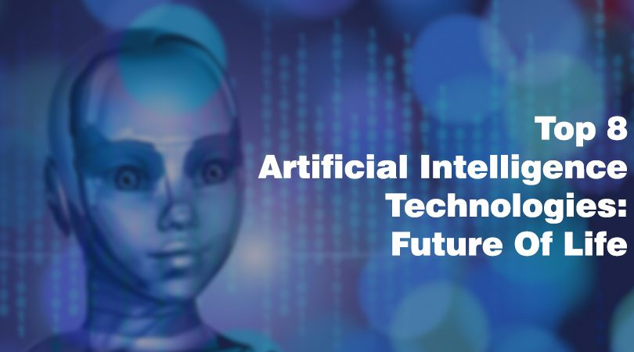

This article is mainly focused to discuss Artificial Intelligence technology or in short AI technology.

What is artificial intelligence?

Artificial intelligence or AI is a technology that deals with computer science that directs in the making of intelligent machines that work and respond like humans.

Some of the artificial intelligence examples are:

* Speech recognition
* Learning
* Planning
* Troubleshooting problems

There are a few artificial intelligence applications like a computer can defeat a world chess champion and understand voice commands on Smartphone, but real AI has not yet arrived. The pace of change is rapid, though.

Some says it will save humanity.

Others say it could destroy us totally.

But without the real advent of AI, we can’t imagine reality.

The market for AI technologies is booming. Besides the hype and the high media attention, numerous start-ups and internet biggies are racing to acquire them; there is great increase in investment and adoption by the enterprises

The term was coined in 1955 to describe a new discipline in computer science field, “Artificial Intelligence” today covers a variety of technologies and tools, and some tested with time, others relatively new. To help know about what’s hot and what’s not, Forrester recently published a TechRadar report on Artificial Intelligence, a detailed assessment of 13 technologies enterprises must consider taking in, to support human decision-making.

Here we share a list of the 8 best AI technologies:

(1) Natural Language Generation: Yielding text from computer data. Presently used in customer service, generating a report, and making a gist of BI insights.

Sample vendors: Attivio, Cambridge Semantics, Digital Reasoning, Automated Insights, Lucidworks, Narrative Science, SAS, Yseop.

(2) Virtual Agents: “In words of Forrester they evolved from simple chatbots to advanced systems that have the ability to network with humans. Now used in customer service and support and in smart home management.

Sample vendors: Apple, Amazon, Artificial Solutions, Assist AI, Creative Virtual, Google, IBM, IPsoft, Microsoft, Satisfi.

(3) Speech Recognition: Transcribe and convert human speech into format necessary for computer applications. Now it is used in interactive voice and response systems and mobile applications.

Sample vendors: Nuance Communications, NICE, OpenText, Verint Systems.

(4) AI-optimized Hardware: Graphics processing units and devices designed and created to run AI-oriented computational jobs. This is now, primarily making a difference in deep learning applications.

Sample vendors: IBM, Alluviate, Cray, Google, Intel, Nvidia.

(5) Deep Learning Space: A special type of machine learning that consists of artificial neural networks with multiple layers. This is now, primarily used in recognising patterns and applications forclassification supported by large data sets.

Sample vendors: Ersatz Labs, Fluid AI, MathWorks, Peltarion, Deep Instinct, Saffron Technology, Sentient Technologies.

(6) Biometrics: This helps more natural interactions between humans and machines that include recognition of image and touch, speech, and gesture. This is now used in market research.

Sample vendors: Affectiva, Agnitio, FaceFirst, Sensory, 3VR, Synqera, Tahzoo.

(7) Robotic Process Automation: They use scripts and different methods to automate human activities to support business processes.

Sample vendors: Automation Anywhere, Advanced Systems Concepts, Blue Prism, UiPath, WorkFusion.

(8)Text Analytics and NLP: Natural language processing or NLP utilise and supports text analytics by helping the understanding of sentence structure and meaning, sentiment, and intent via statistical and machine learning methods. Presently used in fraud detection and security, a wide range of automated help, and applications for mining data not well structured.

Sample vendors: Expert System, Coveo, Basis Technology, Indico, Linguamatics, Mindbreeze, Sinequa, Stratifyd, Synapsify.

There is definitely several business benefits profited from AI technologies in the present times, but according to the survey that Forrester conducted last year, there are so many obstacles to adopting AI as mentioned by businesses and sharing the reasons for no plans of investing in AI:

Statistical report as per the survey:

Absence of defined business case 42%

Unsure about AI application 39%

Lack the required skills 33%

Need to invest in modernizing data management platform

29%

Keep looking into our space for titbits about several news and updates.To know more, keep visiting our [website](http://forummantra.org/) and remain connected by liking our Facebook page @[ForumMantra](https://www.facebook.com/forummantra/).